https://www.facebook.com/profile.php?id=61552493723766&mibextid=ZbWKwL

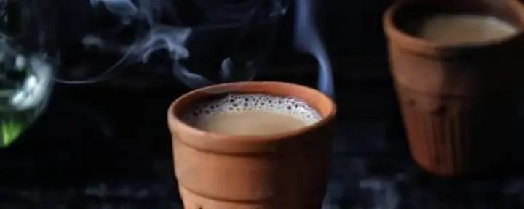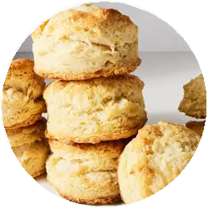

**RD snacks**

Message Us

**RD snacks**

**0** likes **0** followers healthy snacks

fresh snacks

traditional snacks



**Message**



Posts About Photos Mentions

**Details**

**Page** · Health/beauty

Not yet rated (0 Reviews)

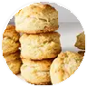**RD snacks** updated their proﬁle

picture.

Oct 11

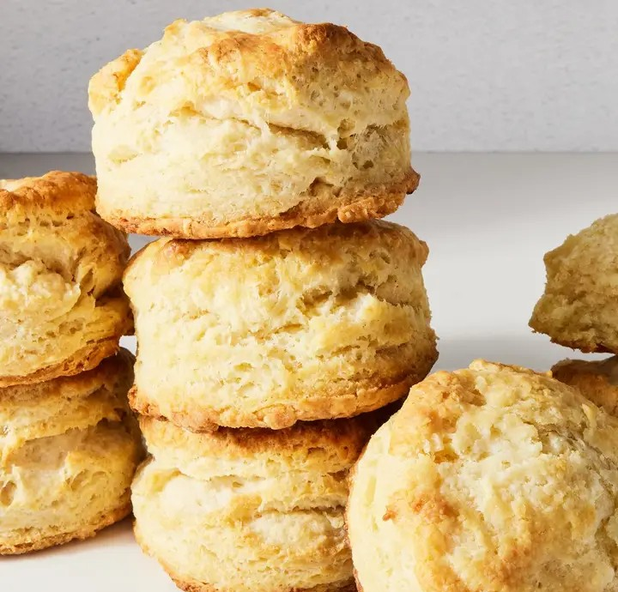



**RD snacks**

Message Us